PORTADA
RESERVA
SHIRAZ; CABERNET SAUVIGNON | Vinho Regional Lisboa | red 2023

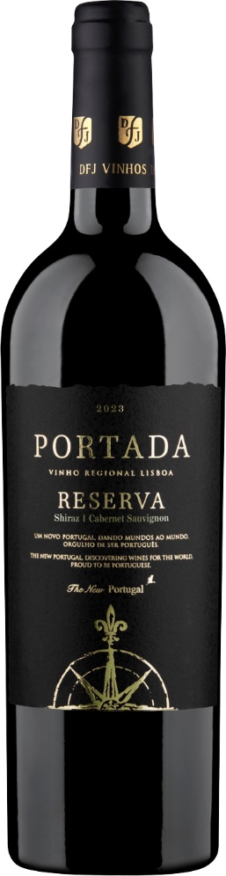
Winemaker: José Neiva Correia
Country/ Region: Portugal/ Lisboa
Terroir: DFJ VINHOS single estates
Grape Varieties: Shiraz 50% e Cabernet Sauvignon 50%

Vinification method:
Classic fermentation method with destemming and pre fermentative skin contact followed of the application of dry yeasts. Fermentation up to 30º C in the first 2/3, and lowering down to 20º C during the last 1/3. During the whole fermentative process, pumping over 2 times per day, using each time half of the volume contained in the vat. After the alcoholic fermentation, the cap is plunged for 30 days, and during that period, extraction of the gentle tannins is conducted, along with the malolactic fermentation and the natural stabilization of the wine. Wine is aged in French oak barrels of 225 Lt for 3 months

Winemaker tasting notes:
Bright, vibrant but elegant aroma to red berries and a few spice notes. It is a great wine, flavourful and velvety, which finishes elegant, intense and persistent. Dark, bright, with an aroma of ripe red fruits and spices. In the tasting it is delicious, velvety and very intense, with an elegant and very long finish.

How to Serve
We recommend it as an aperitif, or as a complement to Tapas, meat, cod, salmon, pasta and cheese. Serve between 14-16ºC. Share responsibly with family and friends.

0

Carton of 6 bottles x 75cl (lay down) | Gross weight: 8.3 kg
Carton of 12 bottles x 75cl (vertical) | Gross weight: 16.40 kg
Case 6 | H 170 x W 310 x L 255 mm ||| case 12 | H 317 x W 333 x L 251 mm
Pallet STD (1.0mx1.2m): case 6 | 16 cases/ level x 8 levels = 128 cases
Pallet STD (1.0mx1.2m): case 12 | 14 cases/ level x 5 levels = 70 cases
Euro pallet case 6 | 12 cases/ level x 8 levels = 96 cases
Euro pallet case 12 | 14 cases/ level x 5 levels = 70 cases
Bottle barcode (EAN13) = 560 0312 19271 1
Carton 6 barcode (ITF14): 1560 0312192718
Carton 12 barcode (ITF14): 2 560 0312 19271 5
FCL 1x20’ = 2100 cartons (on the floor) / 11 Euro pallets / 10 Standard Pallets
ABV at 20ºC%: 13,0%
Volume at 20ºC g/cm³: 0,9972
Dry Extract total g/dm³: 40,4
Volatile acidity in acetic acid g/l: 0,47
Total acidity inTH2 g/l: 6,22
Fixed acidity inTH2 g/l: 5,81
pH: 3,36
SO2 (free) & (total) mg/l: 42/109

